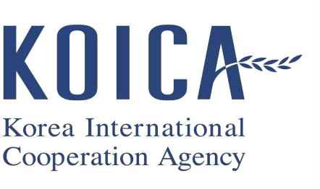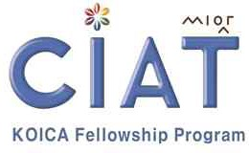

2025-2 K O IC A S c h o la rsh ip
P ro g ram A p p lic a tio n G u id e lin e

Fo r Ma s te r’s, Doctoral D e g re e C o u rs e

05. 2025.

CAPACITY IMPROVEMENT & ADVANCEMENT FOR TOMORROW

Table of Contents

- OVERVIEW

- PROGRAMS AND UNIVERSITIES

- ELIGIBILITY

- SELECTION PROCEDURE AND SCHEDULE

- DOCUMENTS TO SUBMIT

- SCHOLARSHIP BENEFITS

- APPLICATION PROCESS COST

- VOLUNTARY WITHDRAWAL

- IMPORTANT NOTICE

- CONTACTS

OVERVIEW

About KOICA
The Korea International Cooperation Agency (KOICA), established in 1991, is a governmental agency dedicated to providing Korea's grant aid programs. KOICA aims to foster friendly, cooperative relationships, and mutual exchanges with partner countries by offering support for their socioeconomic development. KOICA is involved in a diverse range of initiatives, including the Fellowship Program, Korea Volunteer Dispatching Program, Humanitarian Assistance & Disaster Relief, Public-Private Partnership, and Bilateral and Multilateral Projects, among others.

KOICA Fellowship Program, CIAT
Just like its acronym that sounds like "seed" in Korean, CIAT (Capacity Improvement and Advancement for Tomorrow) aims to sow seeds of hope across KOICA's partner countries. CIAT is a cooperation program that invites policy-makers, public servants, and experts from KOICA's partner countries to Korea for technical training and knowledge sharing. It has established partnerships with numerous public organizations, research institutes, universities, and other institutions in Korea to provide high-quality training programs. In particular, CIAT Scholarship Programs offer various supports to talented government officials from partner countries who wish to study and obtain a graduate degree in Korea. These efforts have resulted in a high level of satisfaction among participants. Upon returning to their home countries, CIAT participants contribute not only to their own societies but also strengthen the bilateral partnership between Korea and their respective partner countries.

Summary of Program Admission Procedure

Step1. Submission of Application Documents and Government Nomination
↓
Step2. KOICA Country Office (Korean Embassy) On-site Interview in your home country
↓ If pass
Step3. Document Screening by the University
↓ If pass
Step4. Local Medical Check-up and Interview (and/or Test) conducted by the University
↓ If pass
Step5. Arrival in Korea, Orientation and Medical Check-up in Korea
↓ If pass
Step6. Commencement of the Degree Program
↓
Step7. Return to the home country

PROGRAMS AND UNIVERSITIES

Duration

Program | Master’s Degree Program | Doctoral Degree Program
Duration | 17 months | 36 months

  - List of Institutions and Fields of study
- Please refer to the CIAT website for detailed information on the institution.
No | University(Institute) | Program | Quota
↓ APPLY NOW ↓
1 | KDI SCHOOL OF PUBLIC POLICY AND MANAGEMENT | Master's Degree Program in Economic Development Policy for Sustainable and Inclusive Growth. | 20
2 | KDI SCHOOL OF PUBLIC POLICY AND MANAGEMENT | Doctoral Degree Program in Economic Development Policy for Sustainable and Inclusive Growth. | 3
3 | HANDONG GLOBAL UNIVERSITY | Master's Degree Program in e-Government and Public Management. | 20
4 | HANDONG GLOBAL UNIVERSITY | Doctoral Degree Program in e-Government and Public Management. | 3
5 | YONSEI UNIVERSITY | Master's Degree Program in Health Policy and Financing Capacity Building. | 20
6 | YONSEI UNIVERSITY | Doctoral Degree Program in Health Policy and Financing Capacity Building. | 3
7 | SUNGKYUNKWAN UNIVERSITY | Master's Degree Program in e-Government and Public Management (2). | 20
8 | INCHEON NATIONAL UNIVERSITY | Master's Degree Program in Capacity building for manage to climate change and environment. | 20
※ Applicants must apply to only one program among the course above.

Where to find KOICA application forms and each University Program Information
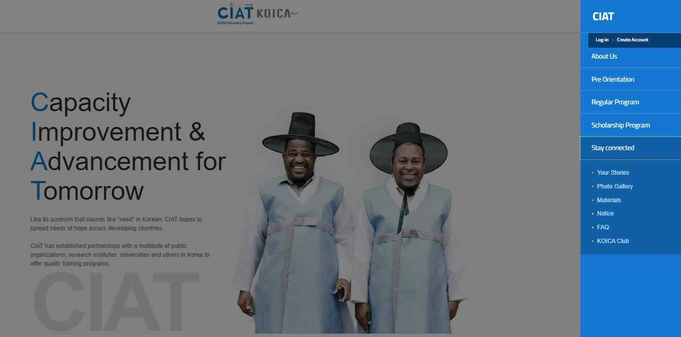
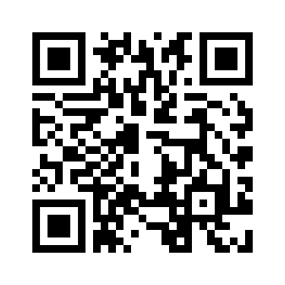
Please visit KOICA’s CIAT website below.
Click http://www.koica.go.kr/sites/ciat/index.do → Menu (Stay connected → Notice)

- ELIGIBILITY

  - Nationality
REGION(93) | List of Designated Countries (2025)
Africa(40) | Ghana, Nigeria, Rwanda, Morocco, Mozambique, Senegal, Algeria, Egypt, Uganda, Cameroon, Republic of Cote d'Ivoire, Kenya, Tanzania, Tunisia, DR Congo, Gabon, Gambia, Niger, Lesotho, Libya, Madagascar, Malawi, Mauritius, Burkina Faso, Benin, Burundi, Sierra Leone, Angola, Zambia, Central African Republic, Zimbabwe, Togo, South Sudan, Liberia, Mali, Mauritania, Sao Tome and Principe, Comoros, South Africa, Botswana
Central & South America(18) | Guatemala, Dominican Republic, Bolivia, Ecuador, El Salvador, Colombia, Paraguay, Peru, Suriname, Honduras, Jamaica, Costa Rica, Guyana, Grenada, Dominica, Belize, Saint Lucia, Saint Vincent and the Grenadines
Asia(13) | Nepal, Timor-Leste, Lao People’s Democratic Republic, Mongolia, Bangladesh, Viet Nam, Sri-Lanka, India, Indonesia, Cambodia, Pakistan, Philippines, Thailand
Pacific(12) | Fiji, Nauru, Niue, Marshall Islands, Vanuatu, Samoa, Solomon Islands, Kiribati, Tonga, Tuvalu, Papua New Guinea, Palau
Middle East & CIS & Eastern Europe(10) | Azerbaijan, Uzbekistan, Ukraine, Jordan, Iraq, Kyrgyzstan, Tajikistan, Georgia, Kazakhstan, Turkmenistan
    - All applicants must be citizens of the designated countries listed below. These countries are selected by the Korean government (KOICA) from the OECD DAC List of ODA Recipients.
    - The list of designated countries is subject to annual changes based on the policies of the Korean government (KOICA)

Employee Status and Government Nomination
    - All applicants must be government officials and receive official nominations from their respective governments for the KOICA Scholarship program.

Age
    - (Preferably) Under the age of 40

Health
    - All applicants must be in good health, both mentally and physically, to study in Korea for the full duration of the program.
    - Applicants with disabilities, but in good mental and physical health, are eligible to apply.
    - Applicants with severe illness are NOT ELIGIBLE to apply.

Minimum Level of Education and Field experience

Program | Minimum Level of Education | Minimum experience in the field of study
Master’s | Bachelor’s Degree | (Preferably) 2 years
Doctoral | Master’s Degree | (Preferably) 3 years after graduation from KOICA  Master’s degree program

- Some programs may have specific educational qualifications, which can be found in the Program Information provided by each university

English Proficiency
- Applicants must have a strong command of English, both in speaking and writing.
- Proficiency in English is required to attend classes conducted entirely in English and to be able to write academic reports and theses in English.

Restrictions
    - Individuals who have previously received a scholarship for a degree program from the Korean government are NOT eligible to apply.
    - Individuals who have previously enrolled in a degree program through a Korean government-sponsored scholarship program, other than the KOICA-administered scholarship program, are NOT eligible to apply for a Doctoral course.
    - However, individuals who have received a bachelor's degree scholarship from the Korean government are eligible to apply for a master's course.
    - Applicants who have passed the local interview* for the 2025-1 KOICA Scholarship Program are not eligible to apply for the 2025-2 KOICA Scholarship Program. *Conducted by the KOICA Overseas Office or Korean Embassy
    - Individuals who were previously KOICA scholars and had their scholarship cancelled* after enrollment are NOT eligible to apply.
*Cancellation of Scholarship means that a KOICA scholarship participant either withdrew from the program or had their scholarship forfeited due to cumulative warnings, etc., during their scholarship period.
    - Applicants who apply to the KOICA Doctoral Degree Program must be scholars who have successfully completed the KOICA Master's Degree Program.
- An applicant who has successfully completed a Master's Degree program funded by KOICA or any other Korean government scholarship is NOT eligible to apply for the KOICA Master's Degree Program.
- An applicant who has cancelled their KOICA Master's Degree program is NOT eligible to apply for the KOICA Master's Degree Program or the Doctoral Degree program.
- An applicant who has successfully completed the KOICA Master's Degree program is eligible to apply for the KOICA Doctoral Degree program.

Preferable
    - Employed by their government during and after the program, engaging in the specialized area of their study as an official servant of their government.

University Eligibility
    - Applicants must meet the criteria set by the university they are applying to and must submit all the required documents as listed in the Program Information provided by the university.
    - It is essential for all applicants to carefully read and understand the application guidelines and Program Information in its entirety.

- SELECTION PROCEDURE AND SCHEDULE

 | Period | Procedures | Details
KOICA  Round | ~Jul. | Application | [Application package submission]  The Application deadline (to KOICA country offices or Korean Embassy): DD MM , YYYY  * The Application procedures may differ for each KOICA overseas office and Korean embassy, please verify the details through the respective office  Prepare all the necessary documents for your admission package and complete the 'Document Checklist.'  Submit the KOICA application package to the KOICA overseas office or Korean Embassy by the specified submission date. Submit the KOICA application package via email to the relevant KOICA overseas office and the Korean Embassy. The submission email address varies for each KOICA overseas office and the Korean Embassy, so please follow the instructions provided by each office.  Contact the KOICA overseas office or the Korean Embassy for more information.
KOICA  Round | ~Jul. | On-site Interview conducted by KOICA overseas office or Korean embassy | Applicants are required to participate in an on-site interview conducted by the KOICA country office or Korean Embassy. However, if an applicant resides in a country where the KOICA country office or Embassy is not present, or lives far from the capital city, they may arrange for a phone interview after consulting with the KOICA Country office or Embassy.
KOICA  Round | ~Jul. | On-site Interview result | The KOICA Country office or the Korean Embassy will send the results of the interview and related documents to KOICA HQ.  *Passing the KOICA overseas office /Korea embassy interview does not guarantee final acceptance
[1st round: Document Screening]
Applicants who pass the interview with KOICA overseas office /Korea embassy interview will be required to submit the necessary documents for admission through the admission websites or via email of university. The University will provide individual guidance to the respective applicants. (The method for submitting documents varies by university)
The university will conduct the document screening process.

University Round |  | Document Screening (University)

(Only for  those who passed the KOICA Round) | ~Oct. | Document  Screening Result | [Preparation for the 2nd round]  The result of the 1st round selection will be announced to the applicants by the University.
(Only for  those who passed the KOICA Round) | ~Oct. | Local Medical Check up | [Medical Check-up]  The applicants who passed the 1st round, must take a medical check-up. The medical examination result will be checked for reference. Some universities may require extra examination. The medical check-up costs are the responsibility of the applicants. The University will provide individual guidance to the respective applicants.
(Only for  those who passed the KOICA Round) | ~Oct. | Interview conducted by the University | [2nd round: Interview]  The university will provide the applicant with details of the interview, including the interview method and the schedule and make the necessary arrangements for the interview. Applicants must follow the instructions from the university. If an individual fails to follow the instructions, it may result in withdrawal from the process. The University will provide individual guidance to the respective applicants.  * Essay tests are mandatory for some universities.
(Only for  those who passed the KOICA Round) | ~Oct. | Interview Result | KOICA HQ will collect the result from each university and finalize the successful applicants.
Final Acceptance round | ~Nov. | Submission of  Original Documents | [Final round]  The original documents required for admission to the university must be sent to the KOICA overseas office/Korean Embassy.
Final Acceptance round | ~Nov. | Admission Notification | KOICA office or Korean Embassy will announce the result of the interview. (It will also be officially reported to the partner country’s government)  KOICA office or Korean embassy will inform the visa* procedure and required documents.  * The participant is responsible for the issuance of an appropriate visa (which must be the ‘Study Abroad Visa [D-2]).
Final Acceptance round | ~Nov. | Prepare Visas and Vaccination | Successful applicants are required to prepare their visas, and must receive additional  vaccinations as directed by the university. Some universities may require extra vaccinations.
Final Acceptance round | 2026. Jan.~Feb. | Arrival to Korea, Medical check-up in Korea.
Final Acceptance round | 2026. Jan.~Feb. | *Applicants who pass the Medical check-up in Korea can start the degree course.
*The written schedule is subject to change based on circumstances etc.

DOCUMENTS TO SUBMIT

List of KOICA Application Documents

[Applicant of KOICA/Korean Embassy Round]
- KOICA Application Forms (Part1~Part4)
※ Applicant’s English name MUST match the name on their passport.
※ Any discrepancy in the applicant’s name (family, given, middle name) will cause a delay in visa processing.
※ All documents required for KOICA round should be submitted via email at KOICA overseas office and Korean embassy. As the procedures may differ for each KOICA overseas office and Korean embassy, please verify the details through the respective office.

- The letter of Recommendation from the applicant’s government. (in charge of ODA or Abroad scholarship program)
- A scanned copy of an applicant’s valid passport.
※ Please DO NOT send an original passport.
    - The passport should be valid until at least 6 months after the expected date of return.
    - Applicants with a passport that will not be valid until the end of the Program are recommended to renew it before departing their home country.
    - Indonesian applicants who are finally nominated as scholarship program participants need to obtain an official passport following the guidelines of the Indonesian government. Indonesian applicants are kindly advised to resubmit a copy of the newly issued passport to the KOICA office and the University once it is issued.

  - Online System or Email Submission of UNIVERSITY Application Documents

[Applicant of University Round those who passed the KOICA Round]
※ University Application document submission is required only for those who have been selected as successful applicants for KOICA overseas office and Korean Embassy.
※ Detailed information will be provided to each individual by the university, so please refer to the university's guidance for specific details. The Application procedures (Online System or Email) vary by each university, so please refer to the CIAT website and Email of University for details.
- University Application form
- Others * Please Refer to Program Information on KOICA CIAT Website.

Submission of University Application & Documents Original Copy

[Applicant of University Round those who passed the University Round]
    - Applicants will receive detailed information regarding the submission via email from the university.
    - Original Copy of University Application & Documents must be submitted to the KOICA overseas office and Korean Embassy in November.
    - The domestic shipping costs for sending the original copy of University Application & Documents to the KOICA overseas office and the Korean Embassy are not supported.
    - KOICA overseas office and the Korean Embassy will send the original copy of your University Application & Documents to the university in Korea. (If the Applicant fails to submit documents, they must send them to the University at their Own expense)
    - Application documents must be submitted in the order of the “Application Checklist provided by the university” which itself should be the front cover of a set of application documents. Please number and label each document in the top right corner.

<IMPORTANT NOTE OF ORIGINAL COPY>

  - Required certificates such as degree certificates or diploma.

- Documents written in English : must be apostilled or consular confirmed.
- Documents written in other languages: ①documents written in a language other than English or Korean must be submitted together with a certified translation. ②obtain an apostille or consular confirmation on the original document and certified translation.
- If your document is unable to be re-issued, please keep the original and obtain an apostille (or consular confirmation) on a notarized copy.
- Please note that applicants who successfully pass the admission process will need to submit an apostilled or consular confirmed diploma and academic transcript in order to obtain a visa and alien registration card. Therefore, applicants are advised to prepare additional documents for the subsequent procedures.

  - Documents to complete such as the Application form
- All forms must be typed in English with the applicant’s original handwritten signature.
※ DO NOT WRITE IN CURSIVE.
※ No need to be apostilled or consular confirmed.

  - Applicants must check the completeness and authenticity of all application documents.
※ If your country belongs to one of the member countries for the apostille Convention, submit your required certificates with apostille.

  - For applicants who submit false documents, the Institution where the applicant belongs will be restricted from recommending new applicants for three years as penalties.

  - Detailed information will be provided to each individual by the university, so please refer to the university's guidance for specific details.

SCHOLARSHIP BENEFITS

Categories | Benefits | Note
Air Fare | Economy class flight ticket  (Based on actual expense)  *At the time  of initial entry/final departure | During the program, expenses caused by the participant’s fault will not be covered.  If a participant wants to change the  flight itinerary, they should pay the additional airfare.
Settlement Allowance | (Master) KRW 600,000  (Doctoral) KRW 1,200,000  /ONCE | KOICA→University→Participant
Monthly Allowance | KRW 1,200,000 Per month | KOICA→University→Participant
Tuition Fee | Full amount | KOICA→University
Extracurricular  Activities* | *Part of the expenses needed for study visits, workshops, Korean language classes and others, except for regular classes | KOICA→University
Accommodation | Universities Dormitory | KOICA→University Condition varies depending on  Universities
Scholarship Completion Grants | (Master) KRW 300,000  (Doctoral) KRW 600,000  /ONCE | KOICA→University→Participant Before Departure
National Health Insurance | Approx. KRW 81,000  Per month | KOICA→University→Participant
Private Medical Insurance | Unexpected accidents or illnesses (benefit may differ to  each case) | KOICA→Insurance company (Claim paid) Insurance  company→Participant
- KOICA only provides the expenses above. Visa expenses, stopover expenses, local transportation, and other miscellaneous expenses will not be covered.
- Scholarship benefits may change under KOICA Scholarship rules and regulations without notice.
- For more Information, please refer to the fellows’ guidebook on the CIAT Website.

- APPLICATION PROCESS COST
KOICA does not provide compensation for all the costs incurred by the selection process (such as document authentication, local medical check-up, express mail service, university application fee and visa fee, etc.) regardless of the outcome. (Pass or fail)

VOLUNTARY WITHDRAWAL
Applicants who wish to voluntarily withdraw during or after the admission process are kindly requested to inform the KOICA office or the Korean Embassy in their respective countries. Please note that the decision is irreversible.

IMPORTANT NOTICE
Due to the nature of the admission process, adjustments related to personal circumstances, such as changes in the examination schedule, deferral of entry, or taking a leave of absence, are not permitted. Therefore, we kindly request that you carefully consider your personal schedule and circumstances before submitting your application.

CONTACTS

General inquiries : koica.sp@koworks.org

/END/

